**FINALS PROJECT DOCUMENTATION**

**COURSE WEBSITE FOR FINALS TOPICS**

Web Systems and Technologies Lecture

9331A

03:00 - 4:00 TF:

Agpaoa, Aldrin

Festejo, Leo Dominique,

Mones, Angelica,

Pagaduan, Jonabelle

Soriano, Ma. Rosmella Jhoy

**Saturday, 12 May 2018**

1. **Architectural Design**

The group used Java Server Pages and Java Servlets for the homepage, login form, main page and the quiz module. The PHP Laravel Framework was used for the registration module. The Bootstrap framework was used for the graphic design elements and layout of the site. And Javascript using JQuery library for the Bootstrap framework’s functionality

1. Java Server Pages / Java Servlets

The group used this technology because of our familiarity with the platform. We used Netbeans IDE for the development. The group used the technology also because of the ease of implantation and deployment of web applications. Database access is also simpler and straightforward since there is a library for such operation. The following pages have been implemented using the said technology:

1. Homepage – This would be the landing page in which the user would be greeted upon entering the URL of the website. The user has two options presented as buttons (Register and Log-in buttons).
2. Main contents page – This page contains the contents of the website. It contains the group’s notes,
3. Log-in module – This module is used by the user to log-in into the website. Prior to logging-in into the website and viewing its contents, the user(s) have to register first by clicking on the Register button. The Log-in module and the register module use a common database.
4. Quiz module – This module will also us the JSP technology in which the database it will use would be the same with the one being used by the Log-In and Register modules. This module would be
5. Laravel PHP

The group has chosen this framework for a fast development of the registration and login sub module. The framework has forms built-in which are available for use through PHP….. The following sub-module has been implemented using the said technology.

1. Registration – This module is would let the user interact with the website by entering log-in information. PHP Laravel would then handle the request to create a table (Create Schema function in MySQL) on the first user to register. Then subsequent registrations are then saved in the said table in the database.
2. Bootstrap Framework

The project group used the Material Design implementation of the framework. This framework was used to make the design and layout of all the module of the website

1. Javascript / JQuery Library – This technology was used in order for Bootstrap functions to work.

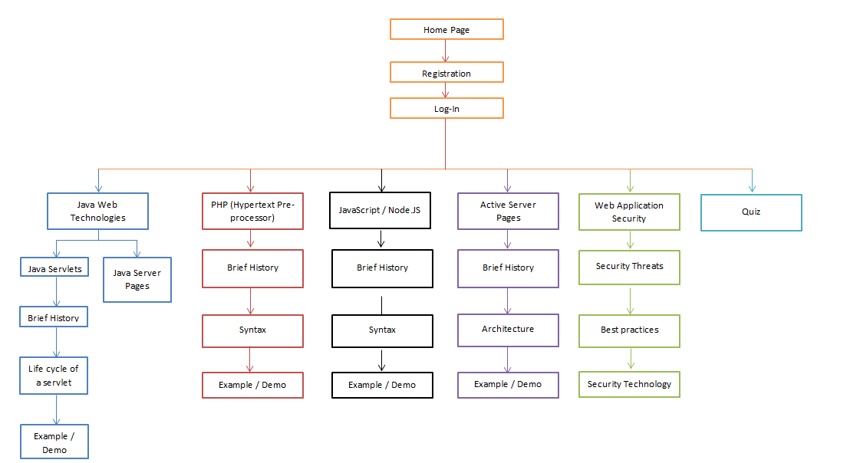

**The course website’s sitemap.**

1. 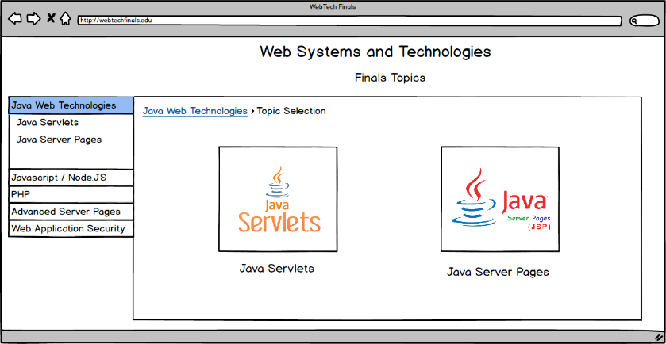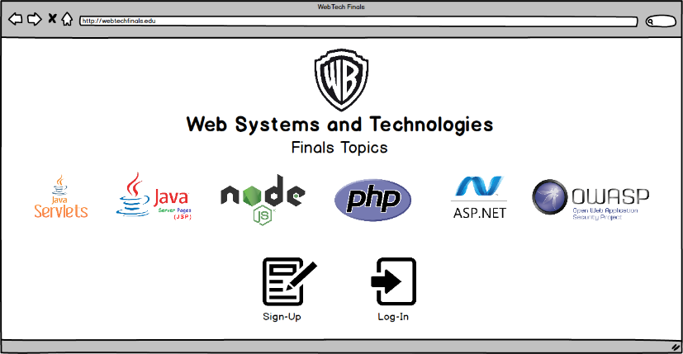**Screenshots**

The group designed the mockup of the course website (using Balsamiq Mockups) as a guidepost for the actual design using code of the course website.

1. **Proof of work**
   1. Commit logs (Github)
   2. Pictures of the group working

